Name-Surname: ……………………………………………………… ID: ……………………………………………

Software Engineering Lab

Direction Lab #4

3rd February 2022

1. Write code in program 4.1 and run it in Visual Studio. What does the program draw in its window?

2. Modify program 4.2 by adding a button which Play/Pause the animation in the window.

- If the animation is running, the button text will be “Pause” and when pressed, the animation will be paused.

- If the animation is stopped, the button text will be “Play” and when pressed, the animation will be resumed.

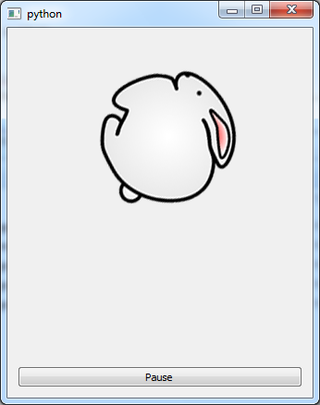

3. Modify Program 4.3 so that when you click on the rabbit (it is hit!), the sound “rabbit_hit.wav” is played. If you click anywhere else, the sound “rabbit_missed.wav” is played instead.

Homework: Design a GUI application based on your Python SE project. Apply what you have learned in this lab to create a prototype GUI program from that design. The GUI should at least contain Image, Animation and Sound.

